# Installing Jenkins on EC2 linux:

* sudo su
* sudo yum update –y

## Installing Git:

* sudo yum install git -y

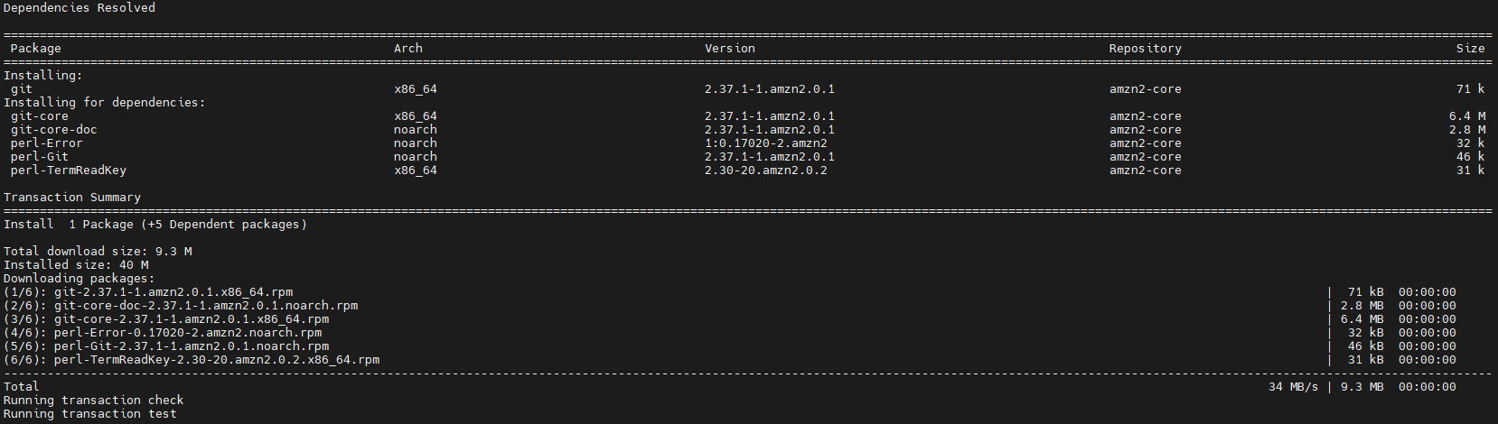

* git --exec-path



## Installing Maven:

* sudo wget [http://repos.fedorapeople.org/repos/dchen/apache-maven/epel-apache-maven.repo -O /etc/yum.repos.d/epel-apache-maven.repo](http://repos.fedorapeople.org/repos/dchen/apache-maven/epel-apache-maven.repo -O%20/etc/yum.repos.d/epel-apache-maven.repo)

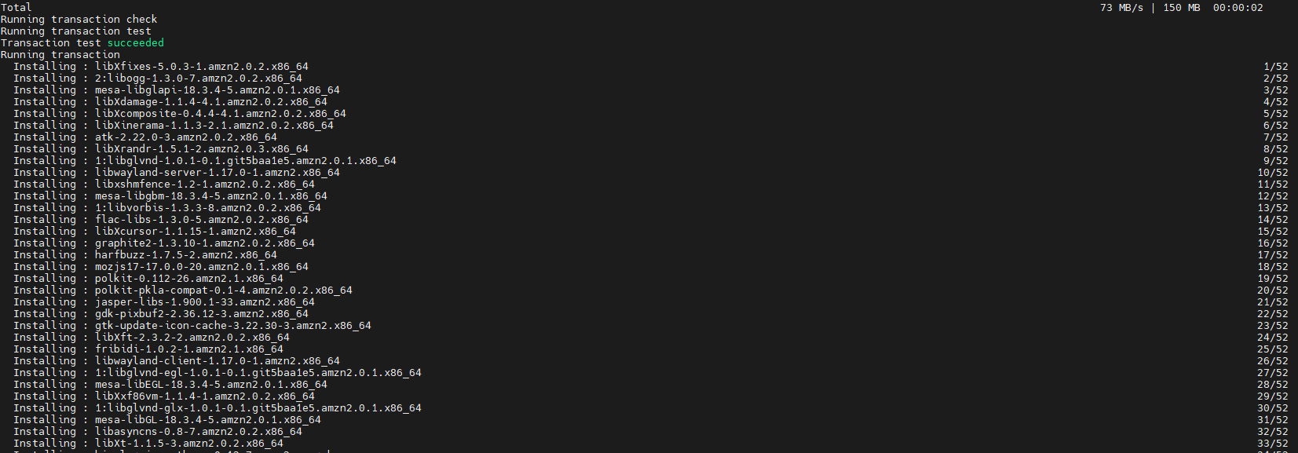

* mvn -version

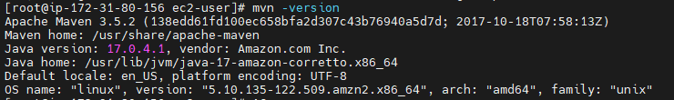

## Installing Jenkins

* sudo wget -O /etc/yum.repos.d/jenkins.repo \

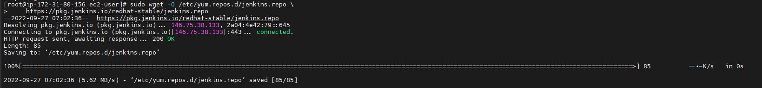

* sudo rpm --import <https://pkg.jenkins.io/redhat-stable/jenkins.io.key>
* sudo yum upgrade
* sudo amazon-linux-extras install java-openjdk11 -y

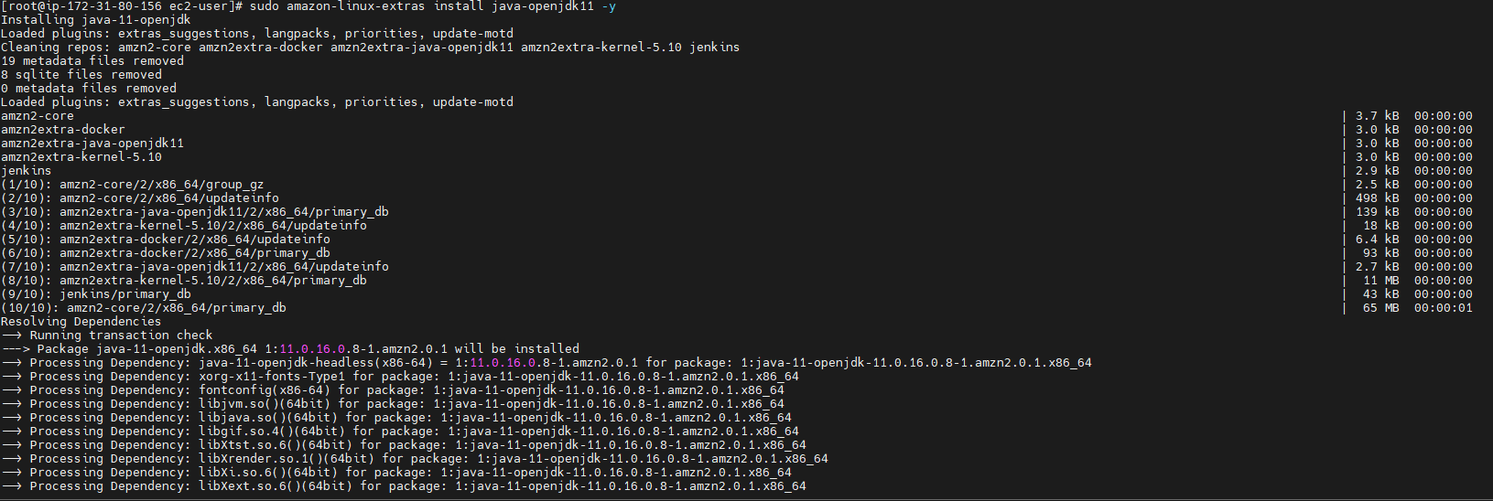

* sudo yum install jenkins -y

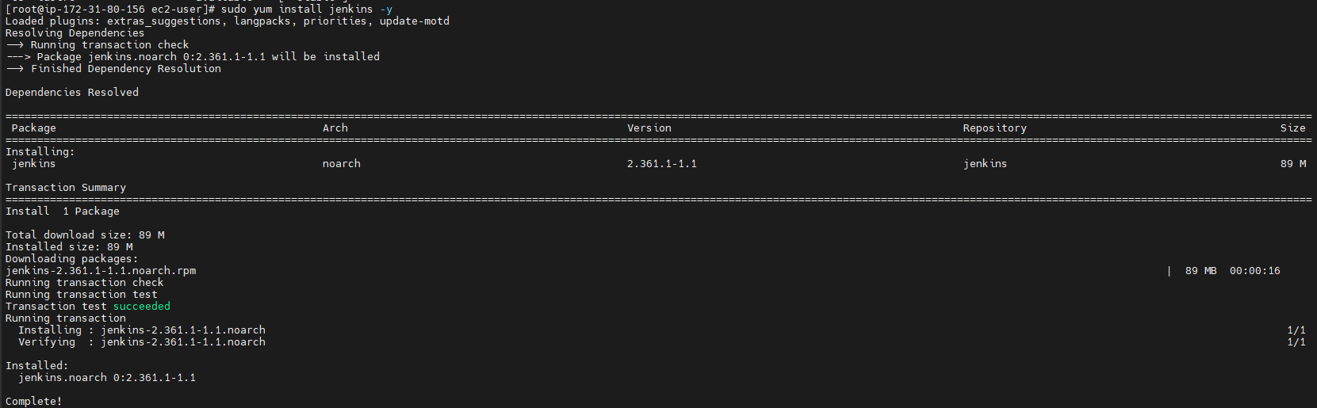

* sudo systemctl enable Jenkins
* sudo systemctl start Jenkins
* sudo cat /var/lib/jenkins/secrets/initialAdminPassword
  + Copy the password returned below



## Configuring Jenkins:

* Connect to http://<your_server_public_DNS>:8080 from your browser. And the following webpage should launch.
* Paste the password that was returned in the linux terminal

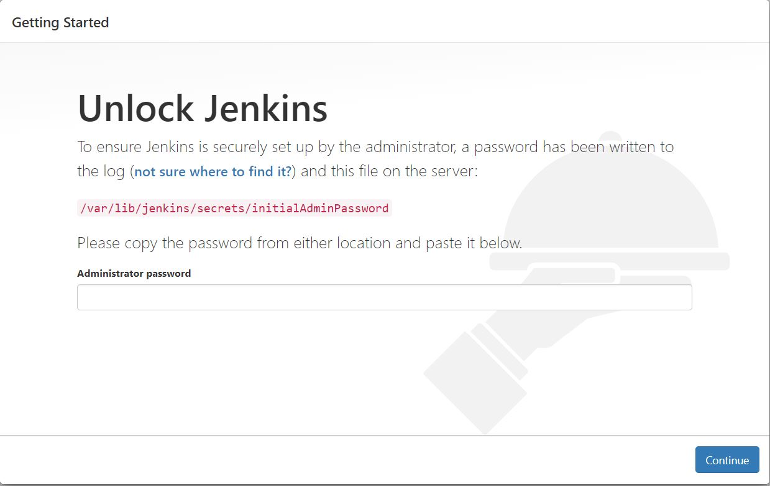

* You will now see a prompt to install plugins, click on “Install suggested Plugins”
* Create an Admin account and Click on “save and continue”

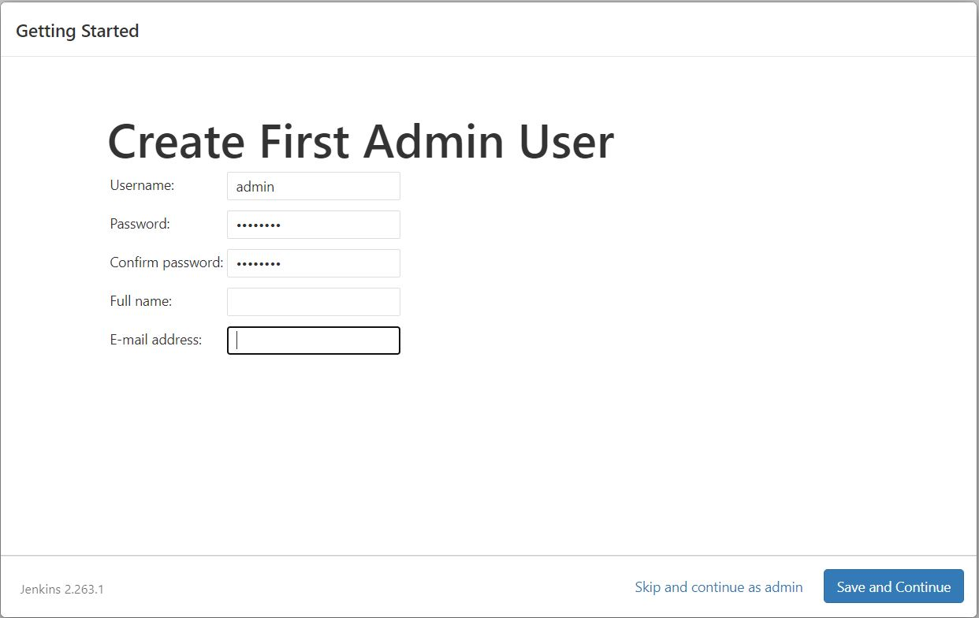

* Once greeted with the home page, Navigate to “Manage Jenkins” on the left Menu Bar

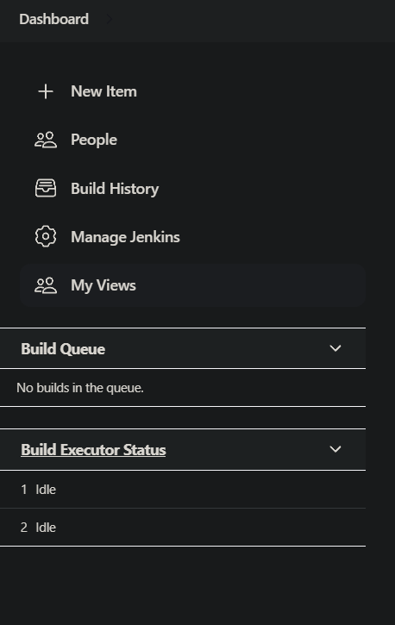

* Click on “Global Tool Configuration”

* Scroll down to “Git”, Click on “Add Git”, Specify a name, and provide the path to your git executable file

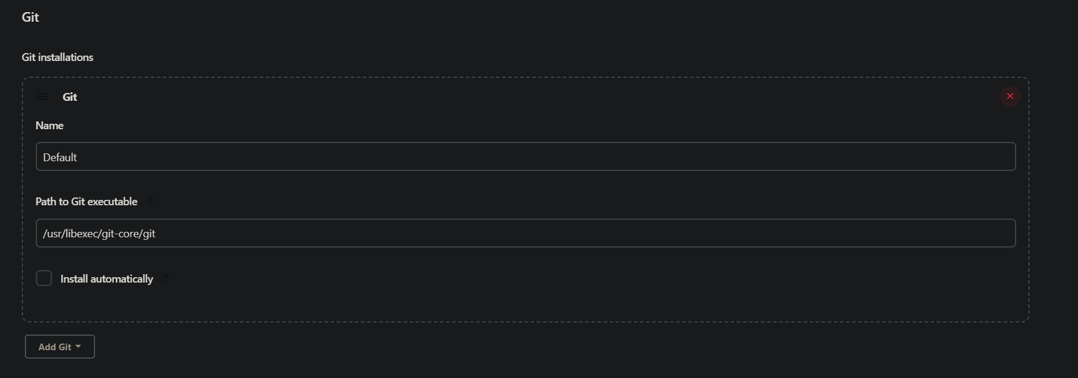

* Scroll down to “Maven”, Click on “Maven Installations”, Provide a name, and provide the path to your maven installation.

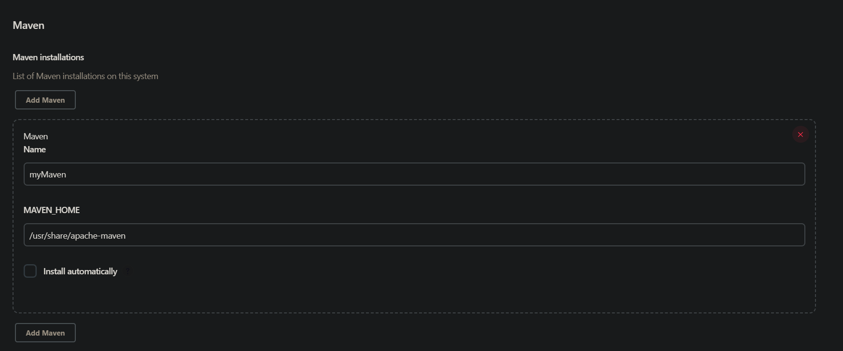

* Click “Apply”, then “Save”
* Once the “Manage Jenkins” page has been loaded again, Click on “Manage Plugins”

* Click on “Available”, and search for “Build Pipeline”, Select the Plugin and then click “install without restart”
* Once the Plugin has successfully installed, you are ready to create your first Pipeline!

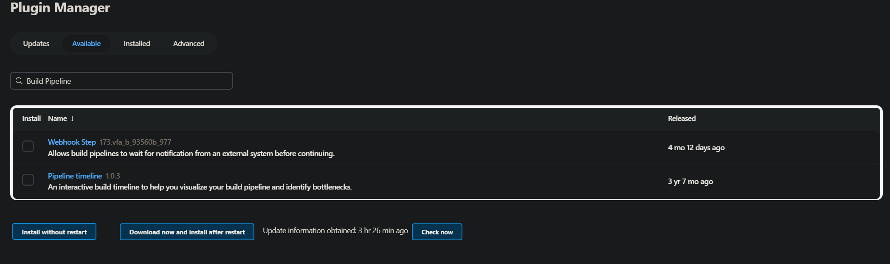

## Creating your first Pipeline:

## Creating Item 1:

### Step 1:

* Navigate to the Jenkins Home Page and click on “New Item” on the top left of the screen

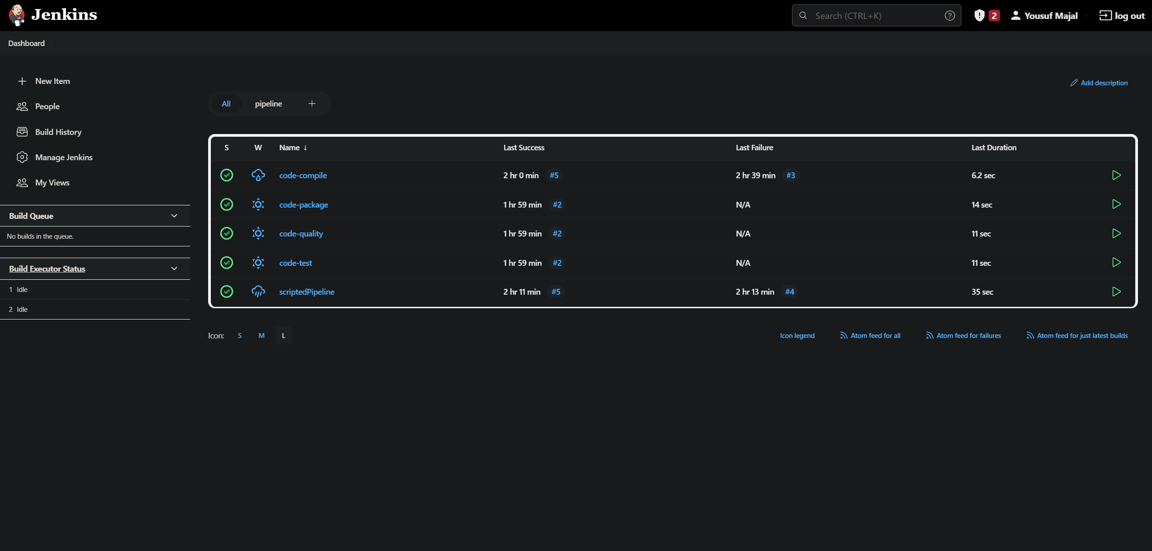

### Step 2:

* Name the Item, and select the “Freestyle Project”, Click “OK”

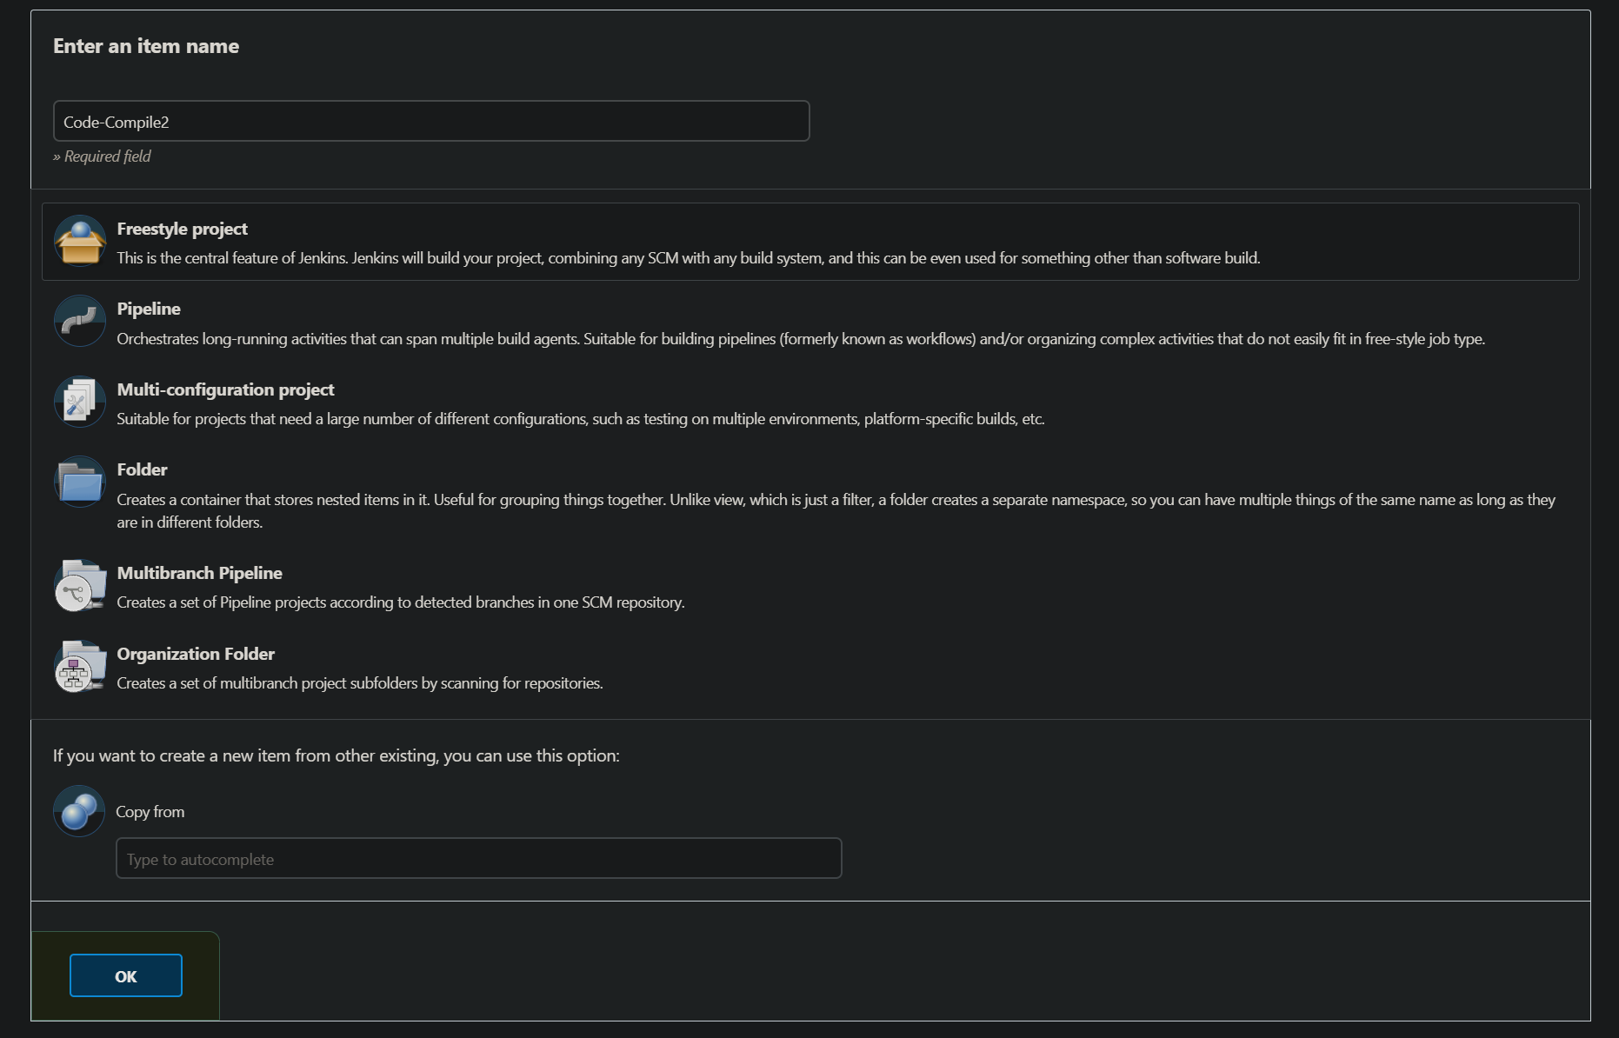

### Step 3:

* Scroll Down to “Source Code Management” and select “Git”, and paste your git repo link in “Repository URL”.

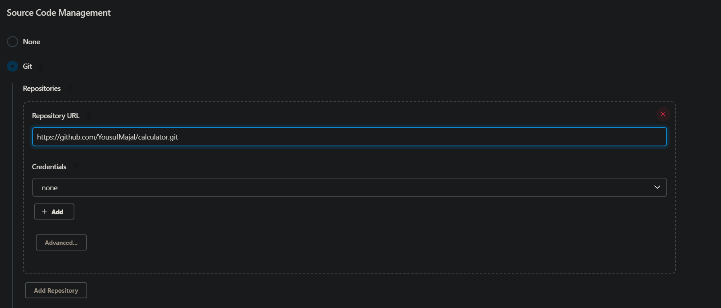

### Step 4:

* Scroll down to “Build Steps”, Click on “Add build step”, and select “Involve top-level Maven Target”
* Select you Maven version as previously Configured, and set the Goal to “compile”

Click “Save”

## Creating your second item:

* Repeat steps 1-3 from *“Creating item 1”*
* Scroll down to “Build Triggers”, select “Build after other project built”, and select the first item name that you created.

* Scroll down to “Build Steps”, Click on “Add build step”, and select “Involve top-level Maven Target”
* Select you Maven version as previously Configured, and set the Goal to “test”

* Click “Save”

## Creating your third item:

* Repeat steps 1-3 from *“Creating item 1”*
* Scroll down to “Build Triggers”, select “Build after other project built”, and select the first item name that you created.

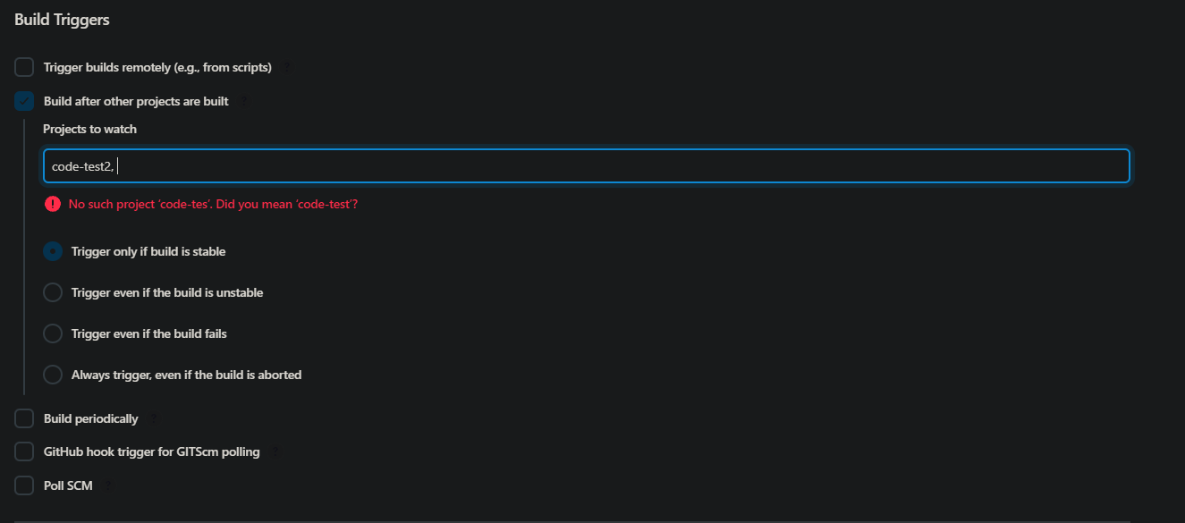

* Scroll down to “Build Steps”, Click on “Add build step”, and select “Involve top-level Maven Target”
* Select you Maven version as previously Configured, and set the Goal to “pmd:pmd”

* Click “Save”

## Creating your fourth item:

* Repeat steps 1-3 from *“Creating item 1”*
* Scroll down to “Build Triggers”, select “Build after other project built”, and select the first item name that you created.

* Scroll down to “Build Steps”, Click on “Add build step”, and select “Involve top-level Maven Target”
* Select you Maven version as previously Configured, and set the Goal to “package”

* Click “Save”

## Creating a pipeline view:

* Click on the “+” icon next to “all” top left of the screen.

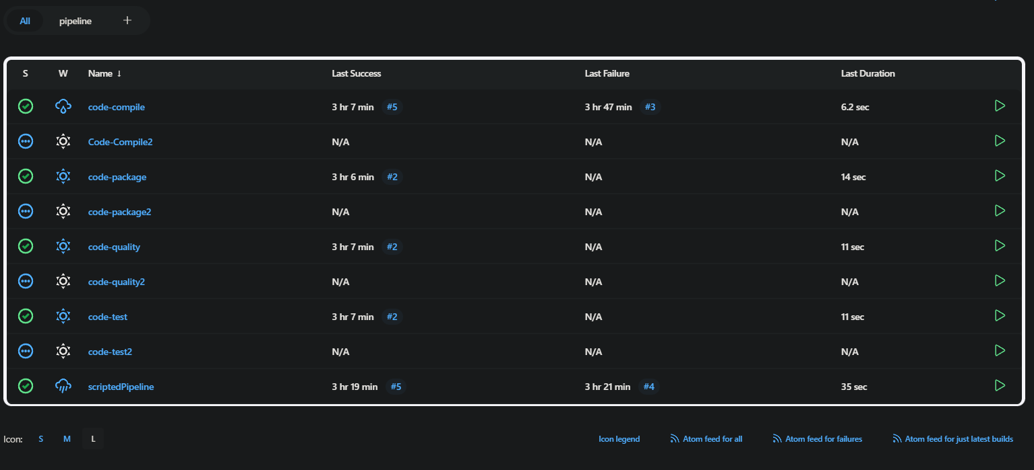

* Select a name for the view, and select “Build a pipeline view”
* Click “Create”

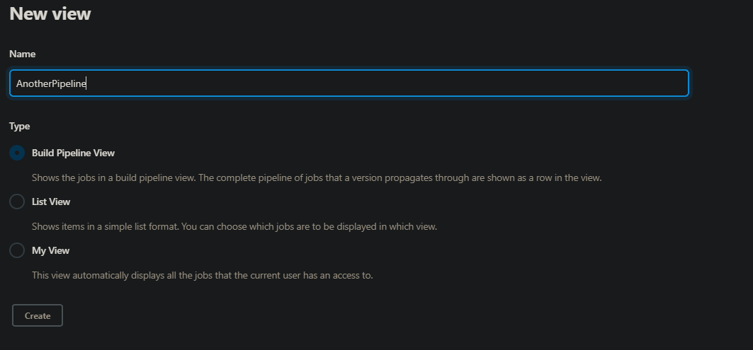

* Scroll to Pipeline flow, and select the first item you created.
* Then click “Apply” and “OK”

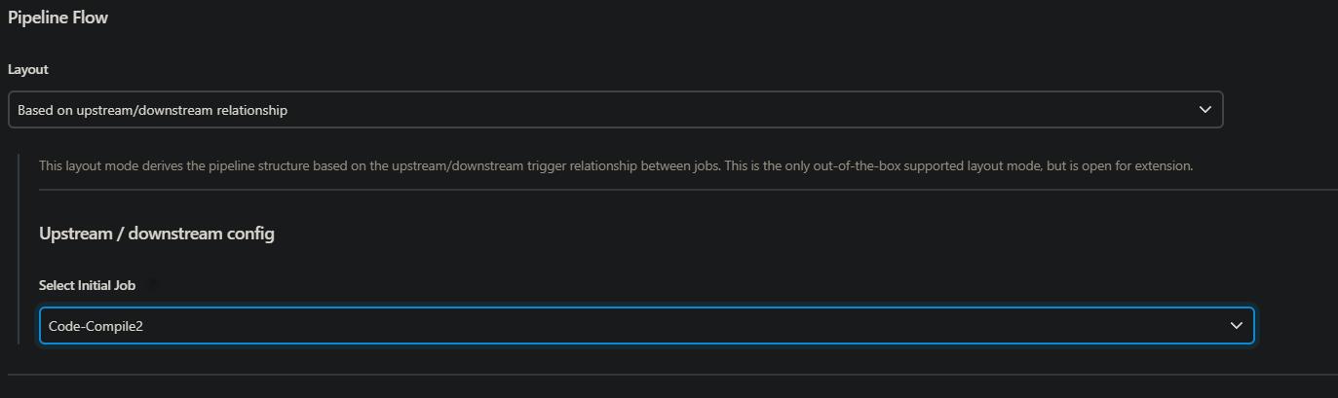

## Run the Pipeline:

* To Run the pipeline, click on “Trigger a Pipeline”
* Refresh until all your items have completed



